ASSIGNMENT

Q1)
C- CODE]

int Z;

void main()
{
int a, b, c;
int p = 6;
int q;
double r;

a = 10;
b = 20;
c = a * b + 25;
p = 6;
q = Z;
r = 34.5;
Z = r;
Z = Z + 1;
}

CFG OUTPUT]

;; Function main (main, funcdef_no=0, decl_uid=1793, cgraph_uid=0, symbol_order=1)

;; 1 loops found
;;
;; Loop 0
;; header 0, latch 1
;; depth 0, outer -1
;; nodes: 0 1 2
;; 2 succs { 1 }
main ()
{
double r;
int q;
int p;
int c;
int b;
int a;

<bb 2> [0.00%]:
p = 6;
a = 10;
b = 20;
_1 = a * b;
c = _1 + 25;
p = 6;
q = Z;
r = 3.45e+1;
_2 = (int) r;
Z = _2;
Z.0_3 = Z;
_4 = Z.0_3 + 1;
Z = _4;
return;
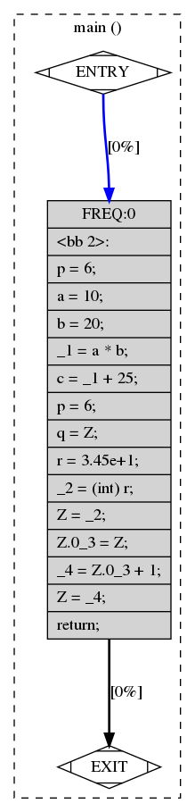
}

SCREENSHOT]

Q2]

C-CODE]
int Z;

void f()
{
int a, b, c;
a = Z;
if (a < 10) {
b = 5;
c = 17;
} else {
b = 6;
c = 20;
if (a == 0) {
c = 0;
}
}
Z = b * 10 + c;
}

CGF OUTPUT]

;; Function f (f, funcdef_no=0, decl_uid=1793, cgraph_uid=0, symbol_order=1)

;; 1 loops found
;;
;; Loop 0
;; header 0, latch 1
;; depth 0, outer -1
;; nodes: 0 1 2 3 4 5 6
;; 2 succs { 3 4 }
;; 3 succs { 6 }
;; 4 succs { 5 6 }
;; 5 succs { 6 }
;; 6 succs { 1 }
f ()
{
int c;
int b;
int a;

<bb 2> [0.00%]:
a = Z;
if (a <= 9)
goto <bb 3>; [0.00%]
else
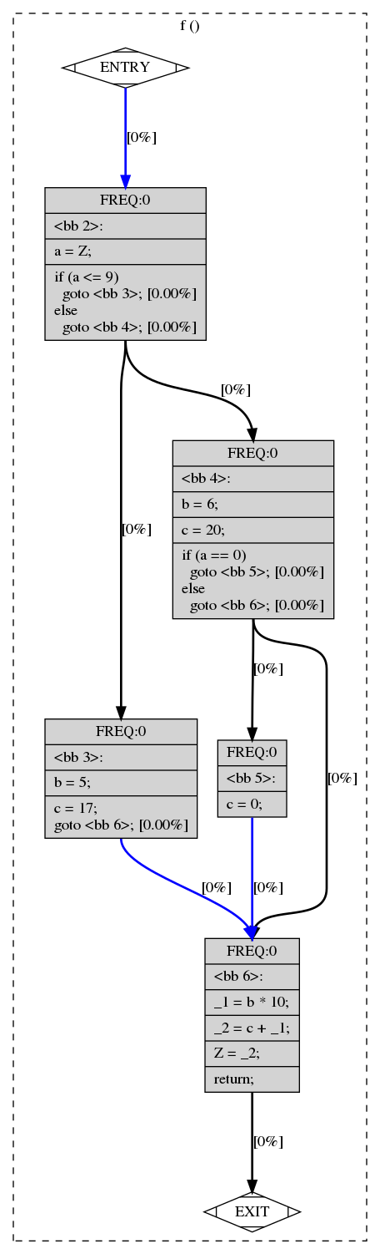
goto <bb 4>; [0.00%]

<bb 3> [0.00%]:
b = 5;
c = 17;
goto <bb 6>; [0.00%]

<bb 4> [0.00%]:
b = 6;
c = 20;
if (a == 0)
goto <bb 5>; [0.00%]
else
goto <bb 6>; [0.00%]

<bb 5> [0.00%]:
c = 0;

<bb 6> [0.00%]:
_1 = b * 10;
_2 = c + _1;
Z = _2;
return;

}

SCREENSHOT]

Q3]

C-CODE]
int main()
{
int sum = 0;
int i, j;

while(sum < 100) {
sum = sum * 2;
}

for(i=0; i<25; i++) {
for(j=0; j<50; j++) {
sum = sum + i*j;
}
}
}

CGF OUTPUT]

;; Function main (main, funcdef_no=0, decl_uid=1792, cgraph_uid=0, symbol_order=0)

;; 4 loops found
;;
;; Loop 0
;; header 0, latch 1
;; depth 0, outer -1
;; nodes: 0 1 2 3 4 5 6 7 8 9 10 11 12
;;
;; Loop 2
;; header 10, latch 9
;; depth 1, outer 0
;; nodes: 10 9 8 6 7
;;
;; Loop 3
;; header 8, latch 7
;; depth 2, outer 2
;; nodes: 8 7
;;
;; Loop 1
;; header 4, latch 3
;; depth 1, outer 0
;; nodes: 4 3
;; 2 succs { 4 }
;; 3 succs { 4 }
;; 4 succs { 3 5 }
;; 5 succs { 10 }
;; 6 succs { 8 }
;; 7 succs { 8 }
;; 8 succs { 7 9 }
;; 9 succs { 10 }
;; 10 succs { 6 11 }
;; 11 succs { 12 }
;; 12 succs { 1 }
main ()
{
int j;
int i;
int sum;
int D.1807;

<bb 2> [0.00%]:
sum = 0;
goto <bb 4>; [0.00%]

<bb 3> [0.00%]:
sum = sum * 2;

<bb 4> [0.00%]:
if (sum <= 99)
goto <bb 3>; [0.00%]
else
goto <bb 5>; [0.00%]

<bb 5> [0.00%]:
i = 0;
goto <bb 10>; [0.00%]

<bb 6> [0.00%]:
j = 0;
goto <bb 8>; [0.00%]

<bb 7> [0.00%]:
_1 = i * j;
sum = sum + _1;
j = j + 1;

<bb 8> [0.00%]:
if (j <= 49)
goto <bb 7>; [0.00%]
else
goto <bb 9>; [0.00%]

<bb 9> [0.00%]:
i = i + 1;

<bb 10> [0.00%]:
if (i <= 24)
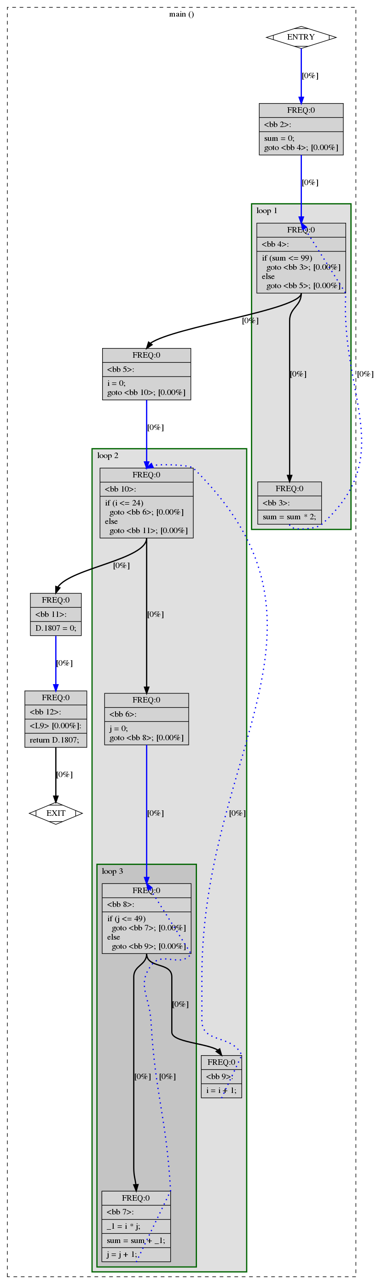
goto <bb 6>; [0.00%]
else
goto <bb 11>; [0.00%]

<bb 11> [0.00%]:
D.1807 = 0;

<L9> [0.00%]:
return D.1807;

}

Q4]

C-CODE]
int main()
{
int a[3];
int b[] = {1, 2, 3};
int i, *p;
for (i=0; i<3; i++) {
a[i] = b[i];
}
p = a;
*(p + 2) = 5;
}

CGF OUTPUT]

;; Function main (main, funcdef_no=0, decl_uid=1792, cgraph_uid=0, symbol_order=0)

;; 2 loops found
;;
;; Loop 0
;; header 0, latch 1
;; depth 0, outer -1
;; nodes: 0 1 2 3 4 5 6
;;
;; Loop 1
;; header 4, latch 3
;; depth 1, outer 0
;; nodes: 4 3
;; 2 succs { 4 }
;; 3 succs { 4 }
;; 4 succs { 3 5 }
;; 5 succs { 6 }
;; 6 succs { 1 }
main ()
{
int * p;
int i;
int b[3];
int a[3];
int D.1802;

<bb 2> [0.00%]:
b[0] = 1;
b[1] = 2;
b[2] = 3;
i = 0;
goto <bb 4>; [0.00%]
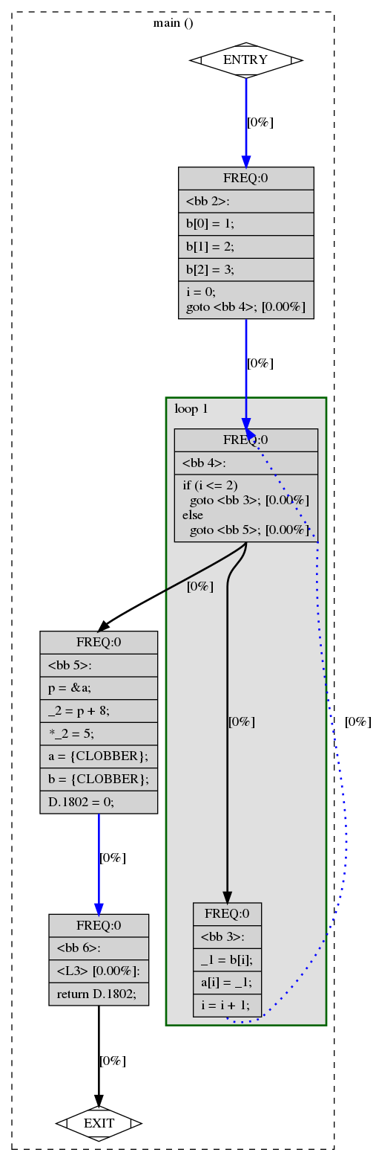
<bb 3> [0.00%]:
_1 = b[i];
a[i] = _1;
i = i + 1;

<bb 4> [0.00%]:
if (i <= 2)
goto <bb 3>; [0.00%]
else
goto <bb 5>; [0.00%]

<bb 5> [0.00%]:
p = &a;
_2 = p + 8;
*_2 = 5;
a = {CLOBBER};
b = {CLOBBER};
D.1802 = 0;

<L3> [0.00%]:
return D.1802;

}

Q5]

C-CODE]

int main()
{
int a, b, c, d;

d = 10;
if (c > d) {
a = 3;
b = 2;
} else {
a = 2;
b = 3;
}

c = a + b;
}

CFG OUTPUT]

;; Function main (main, funcdef_no=0, decl_uid=1792, cgraph_uid=0, symbol_order=0)

;; 1 loops found
;;
;; Loop 0
;; header 0, latch 1
;; depth 0, outer -1
;; nodes: 0 1 2 3 4 5 6
;; 2 succs { 3 4 }
;; 3 succs { 5 }
;; 4 succs { 5 }
;; 5 succs { 6 }
;; 6 succs { 1 }
main ()
{
int d;
int c;
int b;
int a;
int D.1802;

<bb 2> [0.00%]:
d = 10;
if (c > d)
goto <bb 3>; [0.00%]
else
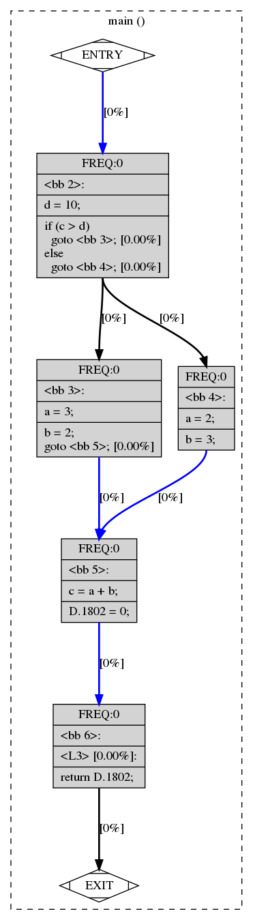
goto <bb 4>; [0.00%]

<bb 3> [0.00%]:
a = 3;
b = 2;
goto <bb 5>; [0.00%]

<bb 4> [0.00%]:
a = 2;
b = 3;

<bb 5> [0.00%]:
c = a + b;
D.1802 = 0;

<L3> [0.00%]:
return D.1802;

}

B-1]

C-CODE]

int AddTwo(int a)
{
a = a + 2;
return a;
}

int main()
{
int x = 3;
x = AddTwo(x);
return x;
}

CFG OUTPUT]

;; Function AddTwo (AddTwo, funcdef_no=0, decl_uid=1793, cgraph_uid=0, symbol_order=0)

;; 1 loops found
;;
;; Loop 0
;; header 0, latch 1
;; depth 0, outer -1
;; nodes: 0 1 2 3
;; 2 succs { 3 }
;; 3 succs { 1 }
AddTwo (int a)
{
int D.1799;

<bb 2> [0.00%]:
a = a + 2;
D.1799 = a;

<L0> [0.00%]:
return D.1799;

}

;; Function main (main, funcdef_no=1, decl_uid=1795, cgraph_uid=1, symbol_order=1)

Removing basic block 3
;; 1 loops found
;;
;; Loop 0
;; header 0, latch 1
;; depth 0, outer -1
;; nodes: 0 1 2 3
;; 2 succs { 3 }
;; 3 succs { 1 }
main ()
{
int x;
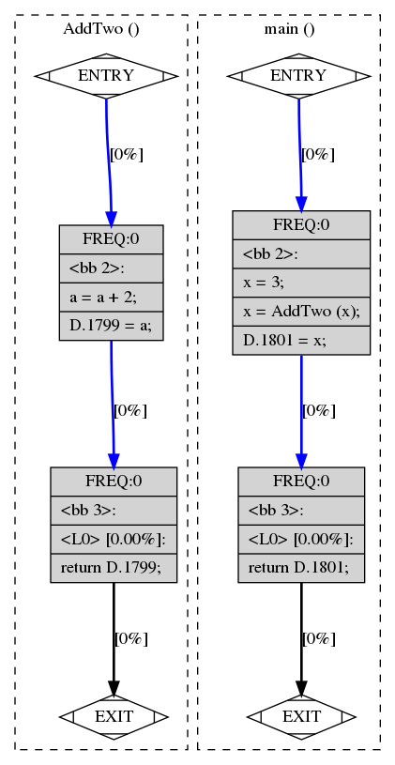
int D.1801;

<bb 2> [0.00%]:
x = 3;
x = AddTwo (x);
D.1801 = x;

<L0> [0.00%]:
return D.1801;

}

B-2]

C-CODE]

int N;

int main()
{
int i, a = 10;
for(i= 0; i < 4; i++)
{
a = a + N;
};
return a;
}

CFG OUTPUT]

;; Function main (main, funcdef_no=0, decl_uid=1793, cgraph_uid=0, symbol_order=1)

Removing basic block 6
;; 2 loops found
;;
;; Loop 0
;; header 0, latch 1
;; depth 0, outer -1
;; nodes: 0 1 2 3 4 5 6
;;
;; Loop 1
;; header 4, latch 3
;; depth 1, outer 0
;; nodes: 4 3
;; 2 succs { 4 }
;; 3 succs { 4 }
;; 4 succs { 3 5 }
;; 5 succs { 6 }
;; 6 succs { 1 }
main ()
{
int a;
int i;
int D.1801;

<bb 2> [0.00%]:
a = 10;
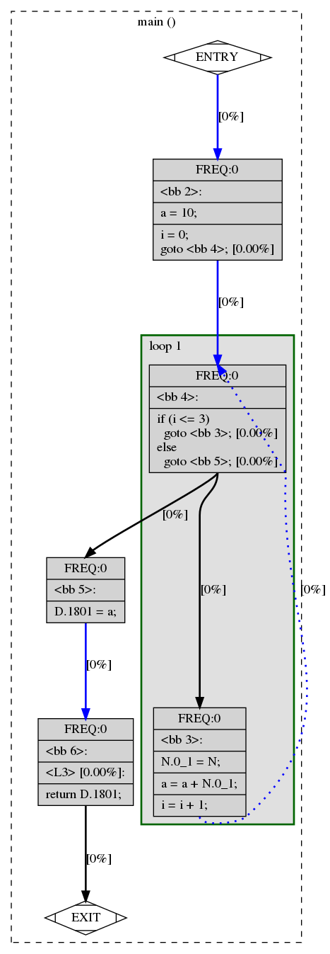
i = 0;
goto <bb 4>; [0.00%]

<bb 3> [0.00%]:
N.0_1 = N;
a = a + N.0_1;
i = i + 1;

<bb 4> [0.00%]:
if (i <= 3)
goto <bb 3>; [0.00%]
else
goto <bb 5>; [0.00%]

<bb 5> [0.00%]:
D.1801 = a;

<L3> [0.00%]:
return D.1801;

}

B-3]

C-CODE]

#include <stdio.h>
int main ()
{
int a, b;
for (a=4 ; a<100; a++) {
if (a < 4)
b = b + 2;
else
b = b * 2;
}
printf ("%d%d", a, b);
}

CFG OUTPUT]

;; Function main (main, funcdef_no=0, decl_uid=2247, cgraph_uid=0, symbol_order=0)

;; 2 loops found
;;
;; Loop 0
;; header 0, latch 1
;; depth 0, outer -1
;; nodes: 0 1 2 3 4 5 6 7 8 9
;;
;; Loop 1
;; header 7, latch 6
;; depth 1, outer 0
;; nodes: 7 6 4 5 3
;; 2 succs { 7 }
;; 3 succs { 4 5 }
;; 4 succs { 6 }
;; 5 succs { 6 }
;; 6 succs { 7 }
;; 7 succs { 3 8 }
;; 8 succs { 9 }
;; 9 succs { 1 }
main ()
{
int b;
int a;
int D.2258;

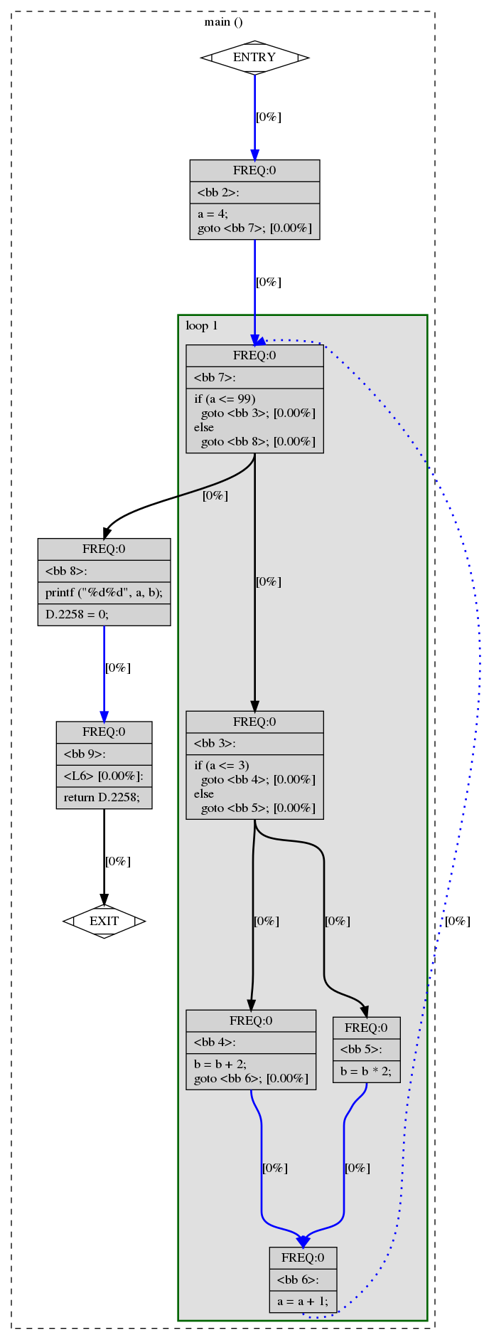
<bb 2> [0.00%]:
a = 4;
goto <bb 7>; [0.00%]

<bb 3> [0.00%]:
if (a <= 3)
goto <bb 4>; [0.00%]
else
goto <bb 5>; [0.00%]

<bb 4> [0.00%]:
b = b + 2;
goto <bb 6>; [0.00%]

<bb 5> [0.00%]:
b = b * 2;

<bb 6> [0.00%]:
a = a + 1;

<bb 7> [0.00%]:
if (a <= 99)
goto <bb 3>; [0.00%]
else
goto <bb 8>; [0.00%]

<bb 8> [0.00%]:
printf ("%d%d", a, b);
D.2258 = 0;

<L6> [0.00%]:
return D.2258;

}

B-4]

C-CODE]

int main()
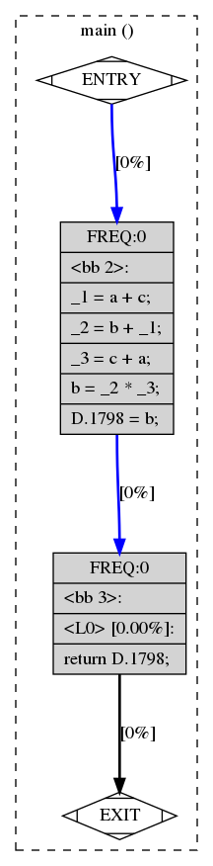
{
int a, b, c;
b = (a + c + b) * (c + a);
return b;
}

CFG OUTPUT]

;; Function main (main, funcdef_no=0, decl_uid=1792, cgraph_uid=0, symbol_order=0)

Removing basic block 3
;; 1 loops found
;;
;; Loop 0
;; header 0, latch 1
;; depth 0, outer -1
;; nodes: 0 1 2 3
;; 2 succs { 3 }
;; 3 succs { 1 }
main ()
{
int c;
int b;
int a;
int D.1798;

<bb 2> [0.00%]:
_1 = a + c;
_2 = b + _1;
_3 = c + a;
b = _2 * _3;
D.1798 = b;

<L0> [0.00%]:
return D.1798;

}

